Introduction To Information Technology (COSC1078):   Assessment 3 – Our IT Project

**The Beach Boyz:**

Chris Turner | Connor O’Loughlin | Sean Shlemoon | Nate Winter | Kowsar Rahman

Contents

Team Profile – The Beach Boyz: 3

Group Processes (of assignment 2): 8

Ideal Jobs: (From Assignment 2) 8

Career Plans: 9

Tools 10

Group Processes and Communications 10

Group Meetings: 11

Project Description: 12

Group Reflections: 17

## Team Profile – The Beach Boyz:

Chris Turner - s3931227

Chris is 21 years old and has started to study for the Bachelor of IT this year. He comes from an English background with their dad being born in the United Kingdom. His hobbies include the usual nerd type stuff such as video games, anime and has enjoyed learning 3D modelling + programming for the past few years on the side. They have had a long-term interest in IT since they were 13 years old with their main IT interests being in object orientated programming, computer hardware and reverse engineering of retro software. Chris went to study a Certificate IV in Information Technology in 2020, and then a Diploma of Software Development in 2021 – both at a TAFE, which is the only ‘formal’ IT experience they have.

***Personality test results*** *– Myers-Briggs, Learning Style, Big Five*

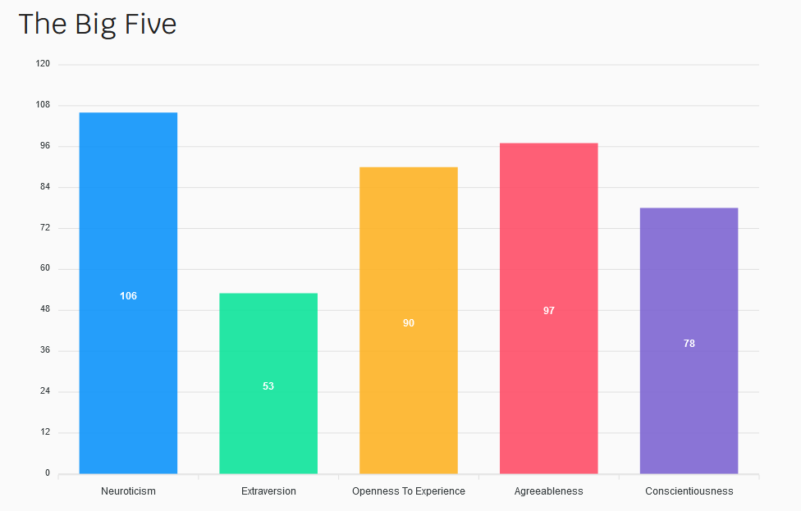

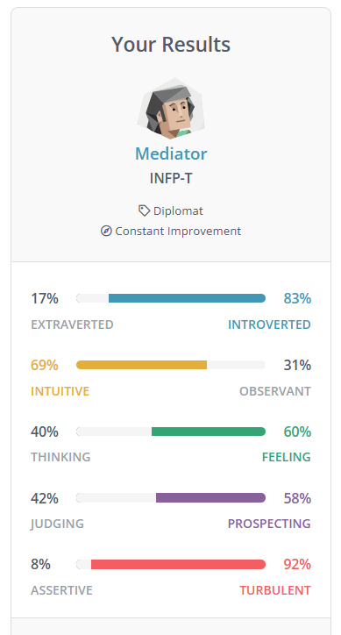

***Test analysis:***

The key take aways from this test to keep in mind while working in a group is the introverted aspect. Working in a group requires all team members to be active and actively communication with each other, solving problems and resolve any conflict that may arise which is the opposite of what an introvert would ‘enjoy’ so to say. It’s possible that the agreeableness is a major trait as they wish to avoid that sort of confrontation, which at the same time may make it hard to provide constructive criticism. It will be important to get out of this comfort zone of being introverted in order to work efficiently as a group, but other team members should also keep in mind this is a foreign/uncomfortable experience for the person as to not too harshly judge them. Being overly self-critical may delay how soon the work gets completed also, which other team members will rely on.

Connor O’Loughlin – s3949499

Connor has recently moved to Melbourne in the last few months in order to study at RMIT for the Bachelor of Information Technology. He is an avid fan of video games enjoys watching the occasional TV series. Connors interest in IT started quite recently when he took Applied Computing: Software Development in VCE last year where he enjoyed the programming aspect the most. The bulk of his current IT knowledge stems from classes he has took in the past where he learnt about different design concepts and a surface level know how of Python.

***Personality test results –*** *Myers-Briggs, Big Five, Learning Styles*

***Test analysis:***

Two of the major characteristics of this team member to keep in mind is the ambitiousness and at the same time how ‘unfocused’ they may be. As this will all be leading to implementing a project idea, it is vital to not come up with an idea that will be overly ambitious for our skill set, and also not get ambitious with the features in each stage of development. Being unfocused also means that they may forget or lack the motivation to keep up a consistent work ethic in a heavily team-based effort (meaning they may need an occasional reminder/push to keep at it). This would also not be a very good pairing with being overly ambitious. This member also scored highly on intellect/imagination which is the exact sort of trait you need in a field of problem solving, which will be a valuable asset.

Nate Winter – s3948929

Nate is a born and raised Australian in a family of 5, with an ancestral history stemming from multiple western European cultures. With a diverse family history, Nate enjoys learning different languages, studying Japanese throughout all of high school and is keen to start learning German. He has been a fan of videos games since he was only 5 years old, playing them to this very day. His interest in IT started at the same time as his interest in video games, finding that he enjoyed tinkering with computers, modifying video games and helping his family with any technical issues that they may have. In high school Nate enjoyed taking software development subjects which he could foresee doing as a career, and wishes to learn about popular languages like C#, C++ and Swift. He also has a side interest in security and networking, spending time outside of school learning about these things.

***Personality test results*** *– Myers-Briggs, Big Five, Learning Style*

***Test analysis:***

From these results, Nate can be interpreted as a shy and introverted person, but still very empathetic, understanding and a team player. This member will be able to understand other members and if they’re struggling, not become frustrated if they are falling behind if not offer to help. It also shows that they can be quite self-critical and pessimistic which is both good and bad. The good is that it means that their work will that of a high standard and will be able to come up with constructive criticism, but may become overwhelmed with critical thoughts and wish to give up which will be important for other team members to keep in mind. They may also need help with poor self-discipline, needing that occasional push himself.

Sean Shlemoon – s3660535

Sean was born and raised in Detroit, Michigan over in the United States with an Assyrian background which is an ethnic/cultural group originating from the Syria/Iraq/Turkey area of the Middle East. Sean enjoys programming (testing out different languages and their best applications), learning about the history of different cultures, playing video games and creating a potential business plan for the future. Sean’s interest in IT has been there since he was 10 years old, being deemed the family “technician” always learning new IT concepts and experimenting (which serves as his prior IT experience). His main IT interests revolve around software engineering and cybersecurity due to how much of the current world relies on these areas of specialty.

***Personality test results:*** *Myers-Briggs, Learning Styles, Big Five*

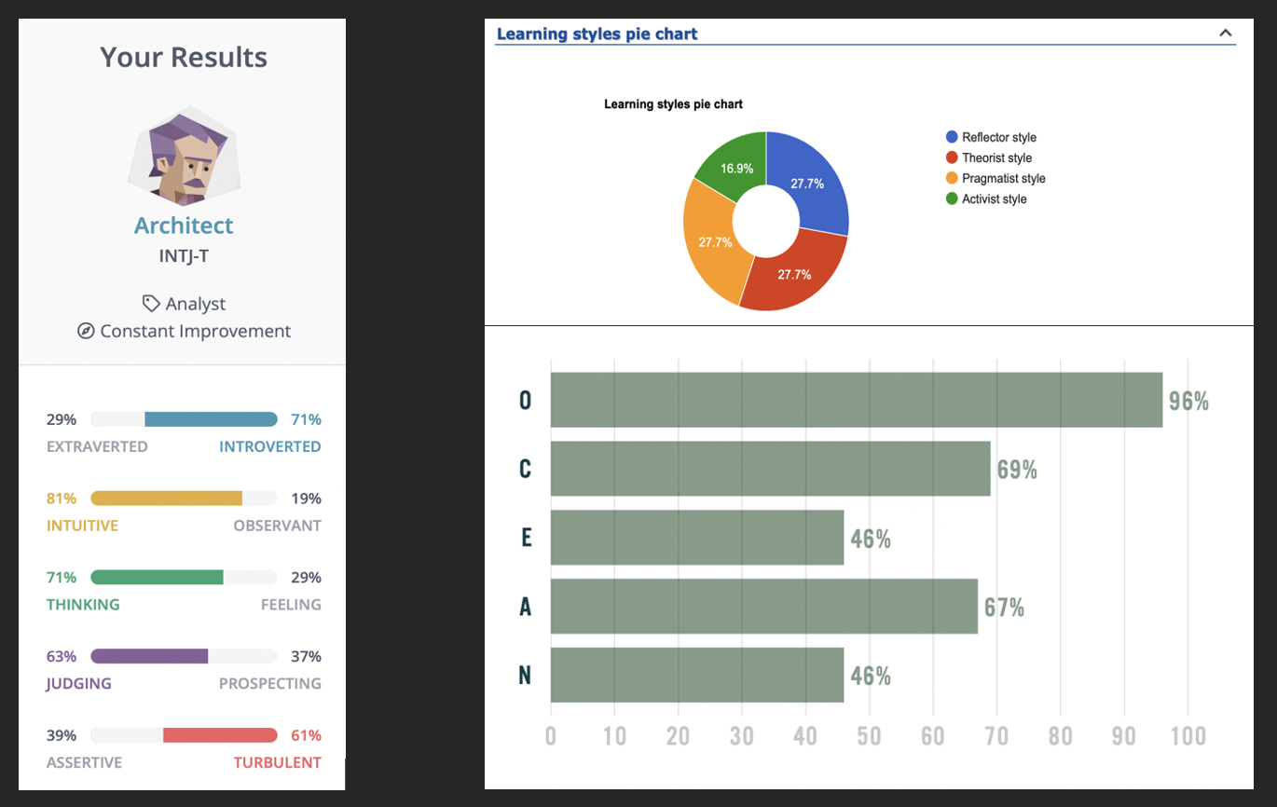

***Test analysis:***

The most notable result from these tests is the conscientiousness aspect. This means that someone is very diligent, thorough and generally a hard worker. There is a very good chance this means that other team members will always be able to rely on them to do a great job. Openness was another important aspect which may very much mean that they’ll always be open to what they are thinking about the task at hand which is a vital thing to have as working in a team means being open to discussion and criticism. These characteristics would make a great candidate for a team leader, and someone you will be able to rely on.

Kowsar Rahman - s3825159

Kowsar is a passionate student originally from Bangladesh who began studying at RMIT in 2019 and is now in his third year of the Bachelor of Computer Science. He discovered his love for IT when he was in year 8, taking a keen interest in web development using languages such as PHP hoping to publish a finished app. This has evolved to additionally knowing Java, JavaScript and Python.

***Personality test results:*** *Myers-Briggs, Big Five*

|  |  |
| --- | --- |
| **Trait** | **Score** |
| Openness | 85 |
| Conscientiousness | 63 |
| Extraversion | 67 |
| Agreeableness | 67 |
| Neuroticism | 60 |



***Test analysis***

Kowsar is the most unique out of this team, getting the Architect (INTJ). This implies that he has a more intuitive, thinking/analytical and critical ways of thinking. These things could be a massive benefit to the team such as the analytical and intuition aspects, especially when it comes to the implementing the project. Creating an IT related project (such as an app) requires an extended amount of careful planning, thinking of how the implementation plan should be structured, how they would go about doing it and developing it. These sorts of skills require a very logical way of thinking, with the critical and pessimistic aspects helping to keeps things to a feasible/realistic scale, discovering any flaws in the plan to as what wouldn’t really work out, and are generally great ways of thinking when it comes to creating an IT related idea (such as with programming). Kowsar would be a valuable asset when it comes to development.

## Group Processes

In assignment 2 our group faced some difficulties, some which were out of our control (personal issues, people leaving, etc) however some of our issues were ones that we could improve on. Our biggest issue was communication. As a group we would either have dishonest communication or little to no communication at all which made it hard to catch up with everyone and check where everyone was at. Moving forward in our group we will need to focus on clear consistent communication so that our progress is clear and defined but also so we can see where every group member is at with their work.

## Ideal Jobs

Chris Turner – Penetration Tester

The ideal job for Chris is that of a “penetration tester” or otherwise known as an “ethical hacker”. The role of a penetration hacker tester is to perform authorized security tests on computer systems/networks in order to find any security vulnerabilities which may lead to sensitive data getting leaked or finances best stolen. Trait Score Openness 85 Conscientiousness 63 Extraversion 67 Agreeableness 67 Neuroticism 60 10 Chris plans on obtaining these skills by continuing to pick relevant courses in higher education, picking up relevant internships when possible, self-study via a combination of textbooks and online courses and attempting to complete previous exams/papers sourced from not only RMIT but other universities out there when they feel confident enough.

Connor O’Loughlin - Systems Analyst/Software Developer

Connors ideal job is to be a systems analyst. The purpose of a systems analyst is to analyze computers and systems in use of the client, determining the best software and hardware to use for the client's needs. This also includes maintenance so everything is up to date, working as expected and looking for anything that could be improved upon to improve the efficiency of the client. Many system analysts are also programmers, creating any specialized piece of software that they may need. His plan for achieving a role like this is by learning intermediate python skills, improving design and presentation skills, and user orientated development via university courses. For the mathematics aspects (statistical modelling) he may need to study outside of university for this using whatever resources that can be found on the internet. The remainder of the needed skills planned to be picked up naturally as he progresses through university.

Kowsar Rahman – Full Stack Developer

Kowsar wishes to become a full stack developer in the future. A full stack dev is simply someone who develops both the back-end side of software (the technical side of things the end user doesn’t see, such as the code or the database) and the front end (most often the stuff the user does see, like the UI/UX with HTML and CSS). It’s what a lot of people think of when they hear “programmer”. Kowsar is already in his final year of university completing many courses and projects both part of university and on the side for fun, meaning he already has many of the skills needed for such a role. His skills could be further refined by further developing more complex projects on the side, attending “code-a-thon" type events and taking on advanced programming and interview challenges (with websites such as Coderbyte or Leetcode).

Nate Winter – Senior Game Development Tools Developer

Due to Nates passion for video games, he would seek out to become a software developer in the video game industry, developing third party tools that game developers over the world use. An example of these tools could be an audio editing piece of software that lets audio engineers and programmers build and implement complex audio systems in a variety of game engines (eg: FMOD). He would also pick relevant courses and electives in object orientated programming, looking for an opportunity to learn the Unity engine via online documentation and videos, and to look for a more entry level game development job upon graduating.

Sean Shlemoon – Software Engineer

Seans ideal job would be something akin to a software engineer at a Silicon Valley type company (such as Google). This is developing their websites or applications that are used by millions of people around the world on a daily basis, with Google also utilizing and coming up with some of the most innovative technology out there. Sean has stated that he plans to gain the skills needed by continuing to study at university, self-studying a wide variety of programming languages via online courses or “bootcamps” (at the moment, Java and JavaScript) and hours of hard work.

## Career Plans:

None of our team’s career plans or ideal jobs have changed since our completion of Assignment 2 and the feedback we got from it. Looking at our career plans more in depth we can see that many of our ideal jobs are similar but still different. The only two ideal jobs that are vastly different from the rest are Chris and Nate’s being senior game development tools developer and penetration tester respectively. For Nate, his strong interest in video games is apparent from his ideal job choice which also reflects his interest in getting into the game development scene. Chris on the other hand has a stronger interest in networks and cybersecurity and rather than developing security systems, he would like to study them and learn how to exploit them for the purpose of securing them and making them better. Because Chris and Nate’s ideal jobs and pathways are very different from the rest of the group it is difficult to contrast or compare them to the others. The only thing that can be observed is that Nate will most likely take some of the same paths as Kowsar and Connor as he improves his knowledge of programming but will eventually divert to game development. Chris on the other hand will take similar paths as Kowsar and Sean but instead focusing more of security and networks rather than user design.

This leaves us with Sean, Kowsar and Connor whose ideal jobs are software engineer, full stack developer and systems analyst/software developer. Kowsar’s ideal job is a full stack developer which entails that his pathway will need to make sure he learns user design, HTML and CSS to a high standard without neglecting the back end of development such as programming and databases. Sean will also need to learn a variety of skills such as user design, HTML, CSS, JavaScript and more to ensure he can achieve his ideal job as a software engineer at Silicon Valley. However, because Sean doesn’t intend to be a full stack developer, he could choose to focus his efforts in specific areas and specialize in them. Connor on the other hand will need to focus on user design and programming skills as well as other skills he may need to pick up outside of this course regarding mathematical analysis. From this we can see that all three of these members will need to improve their skills in programming and web development (to different degrees) however each have their own differences. For Kowsar he needs to learn every aspect of development (front end and back end), Connor may need to divulge in other studies to improve analysis skills and Sean has a choice of either specializing in something he specifically enjoys or is good at or could take a similar path as Kowsar in becoming a full stack developer.

## 

## Tools

For this project, we again set up a website including all the information in the report that each member has the ability to contribute/push changes to. The repository also includes all the files for our artifacts towards the project implementation.

The best way to gauge each team members progress/contribution is to look at the version history of the docx file on SharePoint combined, looking at who has pushed changes to the git and eventually the contribution sheet that will be filled out upon completion of this project. Some members pushed to the git while others stuck to uploading things to Microsoft Teams and then having someone else to push it (as we believe this would have been the most simple/streamlined course of action) or just editing the report document on Microsoft Teams. The git trail is not the best way to represent each individual member's contribution.

GitHub Pages Website: TBD

GitHub Repository: <https://github.com/Sevgi-Z/Assignment3_Project>

Figma Prototype:

<https://www.figma.com/file/iyvkrE6lOdj2S3Qtm6Y1v0/Beach-app?node-id=0%3A1>

## Group Processes and Communications

We once again opted to use Microsoft Teams to facilitate communications and meetings every Wednesday and two-hour face-to-face meetings every Friday. We believe two meetings a week will be sufficient as a minimum, with the Friday one normally being longer and correcting any issues or problems that were brought up on the Wednesday. If anything immediately urgent comes up, we will be able to schedule a sudden meeting or talk about it through the announcements on MS Teams via text. We also decided to end up using Discord as a back and in cases where we need communication and responses ASAP.

If the worst-case scenario were to happen and we lose contact with a team member, then we will have to exhaust all possible avenues of contact including MS Teams, Email, and Canvas if possible.

### Group Meetings:

Assignment 2:

27/04/2022:

<https://rmiteduau.sharepoint.com/:v:/r/sites/FRIAssignment2Group3/Shared%20Documents/General/Recordings/Wednesday%20Meetings%20FIXED-FIXED_20220427_070922.mp4?csf=1&web=1&e=CIUj0R>

30/04/2022:

<https://rmiteduau-my.sharepoint.com/:v:/r/personal/s3931227_student_rmit_edu_au/Documents/Recordings/Saturday%20Catch%20Up%20Meeting_20220430_071020.mp4?csf=1&web=1&e=6Nu5cY>

Assignment 3:

04/05/2022:

<https://rmiteduau.sharepoint.com/:v:/r/sites/FRIAssignment2Group3/Shared%20Documents/General/Recordings/Wednesday%20Meetings%20FIXED-FIXED_20220504_070311.mp4?csf=1&web=1&e=QweVzu>

11/05/2022:

https://rmiteduau.sharepoint.com/:v:/r/sites/FRIAssignment2Group3/Shared%20Documents/General/Recordings/Meeting%20in%20_General_-20220511_170330-Meeting%20Recording.mp4?csf=1&web=1&e=yeV0Jw

18/05/2022:

https://rmiteduau.sharepoint.com/:v:/r/sites/FRIAssignment2Group3/Shared%20Documents/General/Recordings/General-20220518_170810-Meeting%20Recording.mp4?csf=1&web=1&e=cZRAFD

25/05/2022:

https://rmiteduau.sharepoint.com/:v:/r/sites/FRIAssignment2Group3/Shared%20Documents/General/Recordings/Wednesday%20Meetings%20FIXED-FIXED-20220525_171427-Meeting%20Recording.mp4?csf=1&web=1&e=guunv0

## Project:

Overview

For our team project we are attempting to make a beach app that allows users to find the beach that is right for them. This app will have various features such as filtering and search options based on location, popularity.

Motivation:

Australia has many, many beaches, but how do you know which ones are good and which ones are bad? This is our primary motivation when it comes to the building and creating of our beach app. Our goal is to create an app that allows all Australians and Tourists alike to find the perfect beaches to them. This takes the form of allowing users to find the beaches most suited to them. With this beach app we aim to give everyone the best experience possible which is why we include an option to search for a beach based on the characteristics that they want in their summer experience. Do they want a quieter and more comfortable beach, maybe they want a more popular beach in order to meet people. We want to empower our users with the choice of what they think will suit them best.

An additional motivation of our team is to encourage people to get out and start populating beaches again. This is to encourage the growth of Australia's various beaches that may be less popular than they were pre Covid. Many people may have no idea what beaches to go to post covid and which ones to avoid, this app may assist these kinds of people with up-to-date information that can assist them in finding what beaches are best in this post covid era.

Landscape:

In terms of similar products, the range of competitors is vastly limited. However, there is one competitor that has been found is the “BeachSafe” app, this app tracks similar information like attendance and statistics relating to the beach and weather itself. Where our applications differ however is regarding the uses of each app ours differs slightly with the BeachSafe app showing the closest beach that is safe and patrolled whereas our app is more focused on giving a more holistic view of the various beaches in Australia.

Aims

For our project our aim is to build a functional prototype of our app in android studio. To do this we will also need to make UI wireframes in figma, database model, XAMPP server and database implementation, use case diagrams and a process flowchart. The UI wireframe will allow us to create artifacts of our application in case we don’t end up completing the full app and it also will help picture and design how the UI will be in the app. Both process flowchart and use case diagrams will give us additional artifacts and will also specify how the code and database will be designed.

Plans and Progress

For our project, we decided to go with a beach application that is all about finding the ideal beach site that suits the user’s needs and whether they would recommend it to other beach goers. It will be able to locate a certain type of beach that is based on a particular set of search criteria provided by the user and will give a list of the most suitable beaches within a given location proximate to the user. The app will also be able to give the user the ability to leave reviews of the different beach sites that they visit and in addition take and upload photos of the beach for other users to check when searching for their own ideal beach. The search criteria are a crucial part of the application, as it is the main function of the application in producing the specific beach the user had in mind. At this stage, we are at the beginning of development for the application. We will be utilizing Android Studio as the framework for the app and it will be written in Java. As part of our prototype development, we have decided to go ahead and utilize Figma as the UI presentation of what we envision the layout will look like. Using Figma helps us out tremendously in seeing what the end product would look like for the app UI and allows us to make any changes we see fit necessary. As for the usability and functionality of the app, we are currently going through the developmental process and will be providing updates as we advance. For each group member, we had assigned certain tasks to one another for completion. Chris had the tools and project (roles, time planning/deadlines, communications) sections of the report, mentioning the several types of applications we were using for the development of the app and the overall structure of the project report. Connor was responsible for the tools and technology section as well as the overview part of the report, in addition he was also the creator for our prototype using Figma. I was responsible for the risks, scopes and limits, testing, plans and progress sections of the description for our report. Nate had the aims section for the project description and the team profile. Kowsar was assigned the skills and jobs portion of the report as well as the contributing collaborator on GitHub for the development of the beach application. Prior to deciding to go with a beach app, as a team we initially considered creating a video game. We had assigned certain tasks to each other and really started to provide ideas for the game such as artwork for the backgrounds, a scoring system, save system, as well as a database to store the information required. We were planning to use Android Studio and wanted to create it as a 2D platformer video game but as the days went by, we immediately realized that we were unable to continue with the idea as it would have been time consuming and additionally, we had little experience with Java.

Roles

For this project, we aimed to have the roles akin to:

**Chris Turner** – Project management, database designer

**Connor O’Louglin** - User Interface Designer

**Nate Winter** – User Interface programmer

**Sean Shlemoon** – Use Case + Tester

**Kowsar Rahman** – Lead software developer

The justification for these tried to play to people’s strengths. For example, Chris has been the team leader and organized much of the logistics to this point with good success, Kowsar has extensive experience developing software and Connor has a more artistic/creative leaning side which would be good for user interfaces. The roles of Nate and Sean weren’t assigned necessarily with any strengths or their ideal jobs in mind as we couldn’t find any suitable tasks.

Although these roles didn’t end up being set in stone. This could be attributed to life obligations getting in the way, poor project management, not keeping up with deadlines and not having a very clear vision to as how we were going to go about developing the project.

Scope and Limits

As with any project we come across, our actions will determine what will be completed and what will be left out from development. The amount of arduous work and dedication we put into creating this application will be the same amount in culmination that we will receive from it. Of course, the only thing preventing us from finishing every feature we wish to include is the time we have available. Our app, as simplistic and trivial as it may be, has the possibility to possess many distinctive functions and features that will enhance the beach going experience for the user. The problem comes from false promises we make to ourselves and to others on delivering those said features and overcommitting to its capabilities. In order to avoid as much of this as possible, we have set certain limits to the development of the app and ensure our priorities are not out of hand. One of those limits that we have in mind is the user’s ability to save their favorite beach spots as well as giving the user the search criteria selection. We will not be able to have an overall search of different beach sites across all of Australia, but we will show the map spots of highly rated beaches listed on Google. Using Google Maps API, we can also display the map integrated with our UI and have a navigation bar at the bottom that will allow the storage of ideal beach sites. The app itself would be a skeletal prototype with considerably basic functionality, since at this stage a fully-fledged out beach application would be time consuming in including the distinct functions Google offers with its API.

Tools and Technologies

The tools and technologies needed for this project include Java (the programming language), Google maps platform, Android studio and Figma. In this group both Christopher and Kowsar have experience with Java as a programming language and as Java is an open-source programming language no license is needed for the use of this technology in our project. In terms of Figma, all members of our group should have at least an idea of what it is with variable ranges of experience due to it being used for our UCD course, this may exclude Kowsar as he is from a computer science degree and may not have taken the class. Conceptually, Google maps platform may be needed in this project and does require payment to use certain features, nobody in our group has prior existing experience in the usage of this platform and it is unknown whether it is truly required for this project. Finally android studio is another technology that is required for our project. In this group Kowsar has demonstrated that they already have some pre-existing knowledge of how to use this technology. In terms of licenses required for the use of this technology, no license is needed apart from a one-time $25 registration fee that is required to upload an app to the Google Play Store, however, as we are only creating a prototype of said app there is no need for such a license to be paid.

Testing

When it comes to how exactly we will be testing our project, one of the most basic ways is while we are writing the code for the application. During programming, we will be running debug sessions if we come across a coding issue that does not seem to have a solution initially. As a group, and especially those with some coding background familiar with the language being used, we will come together and go through each line of code until we figure out what is causing the whole project to stop working. As we progress further in development, we will produce a trivial prototype that will still have the basic functionality of the final product but will not be as clean and practical as we intend. The purpose of this prototype would be to see how the app works in a real-world situation with genuine users interacting with it. The users that will test the app will be a combination of people we know and are familiar with, random strangers that are willing to give a quick play through, those who are avid beach travelers, and those who simply like the user interface and would want it to be implemented onto other industries. This will provide us with realistic data that can be utilized in finding out what is being perceived positively and what can be flushed out of the system if the reception is poor. The testing protocol will be implemented throughout the course of the development of the application, mostly because it will keep us sharp and honest about the functionality of the app and allows us to find any issues that may exist at a much earlier stage rather than before we launch the product.

Timeframe/Deadlines:

|  |  |  |  |  |  |
| --- | --- | --- | --- | --- | --- |
|  | **W1** | **W2** | **W3** | **W4** | **W5** |
| Chris Turner | Finish pre-development documentation | Database Model | Database creation via XAMPP/phpMyAdmin | Database implementation in the app itself | Bug fixing |
| Connor O’Loughlin | Finish pre-development documentation | UI (User Interface) Wireframes (probably going to be done after prototype) | UI prototype via Figma (or a similar website)  (Done before wireframe) | Bug test | Bug fixing |
| Nate Winter | Finish pre-development documentation | Create rough mockup in android studio of UI going by the wireframes | Implement UI to fit closer with the Figma prototype | Bug test | Bug fixing |
| Sean Shlemoon | Finish pre-development documentation | Use case diagrams | Software testing | Bug test | Bug fixing |
| Kowsar Rahman | Finish pre-development documentation | Begin functionality development on app via Android Studio, laying out the framework | Continue development, changing anything to fit with completed tasks. Implement database functionality if ready. | Bug test | Bug fixing |

We assigned these tasks based on our strengths and weaknesses as touched upon in the “Roles” section, but also taking into account that all but one has no experience whatsoever planning software projects or to as how the development life cycle works. We also had to consider that we didn’t have the chance to start on this project earlier, giving us a late start. We were not sure to put on future weeks after the submission deadline as again, nearly all of us have zero experience in software development, what to expect or how to break the tasks down. Development on the software side of things advanced faster than expected seeing as how we handed that off to the person with actual experience.

Risks

There are a few risks that we may come across when developing this beach application. One example could be the focus we have had on creating this app with the intention of it being only available for smartphones and having a mobile UI. Since the app is centered around the environment of a beach, most if not all beach goers are bringing their phones with them. This justifies the focus for a mobile app, but it can be a dangerous approach if we decide to not also include a webpage that is similar in presenting the information akin to a travel agency website. Another risk worth mentioning is in regard to the actual development of the application. We have run into several issues of understanding the different programming languages that we have at our disposal and whether they have the capability to execute the various features we wish to have as part of the app. Ensuring that we fully understand the language we use to create the app is crucial and a fundamental part of the developmental process. We could mention plenty of other risks that can potentially cause mayhem, but one important subject to cover is the risk of a serious security violation. Any type of breach in security that can cause harm to the user and expose their personal information and data is something we must take into consideration, and one solution that we decided to go with is the anonymous factor of leaving behind reviews. This allows the user to not have any association to their experience at any beach that they visit, thus preventing any sensitive information being leaked.

Skills and Jobs

4 positions needed that are required to take the project to the next level are:

Business Analyst: The person responsible for analyzing the market and producing reports on the business data. Must know how to use tools like Excel, Power BI, etc. Must have a basic understanding of the market and willingness to do research to gather insights.

Frontend Developer: Responsible for creating designs with the most appropriate pattern that increases the usability of our applications. Must be proficient in any framework like React, Angular, Vue, etc.

Backend Developer: Maintaining databases, securing APIs, and deploying our infrastructure to the AWS/GCP cloud premises. Must be proficient in any popular languages like Java, Python, or JavaScript. Should be familiar with REST APIs. It is recommended to have skills in either AWS or GCP as our infrastructure will be based on the cloud entirely.

DevOps Developer: Must have skills in CI/CD tools like CircleCI, Docker, Kubernetes, Jenkins, etc. DevOps teams are responsible for building, testing, and maintaining a CI/CD pipeline and the overall reliability of IT infrastructure.

## Artifacts

All artifacts will also be available on the GitHub.

Artifacts of Chris:

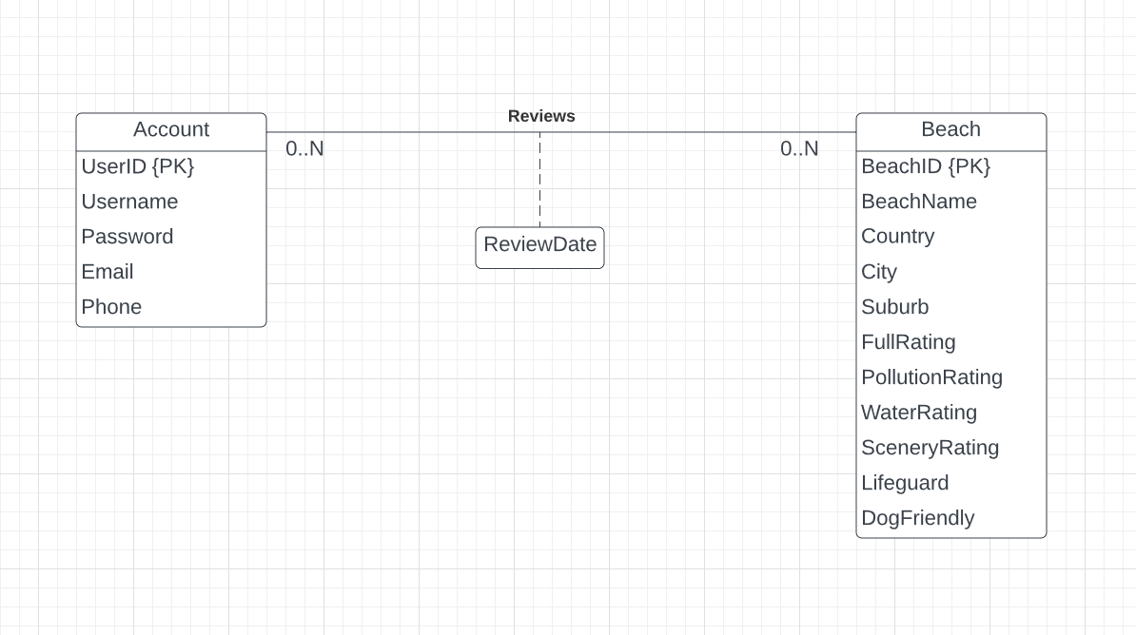

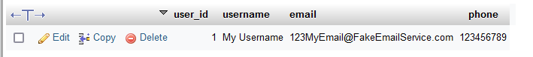



See “Database Schema and Commands.docx” for full artifact.

Artifacts of Connor:

Wireframes:

Figma:

<https://www.figma.com/file/iyvkrE6lOdj2S3Qtm6Y1v0/Beach-app?node-id=0%3A1>

Artifacts of Sean Shlemoon:

## Artifacts of Kowsar:

Apk file of the app: <https://github.com/Sevgi-Z/Assignment3_Project/blob/main/app-debug.apk>

It may show some security reasons if trying to install as the app is not published on play store nor it is protected by Play Protect.

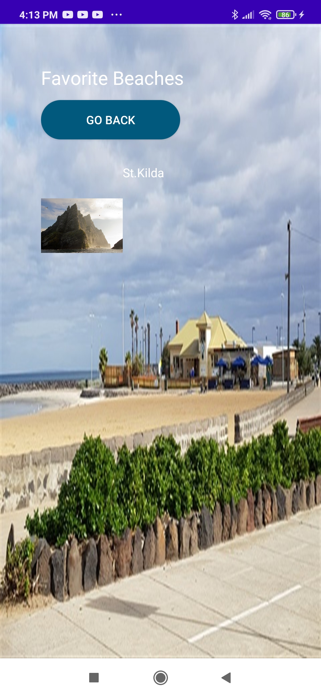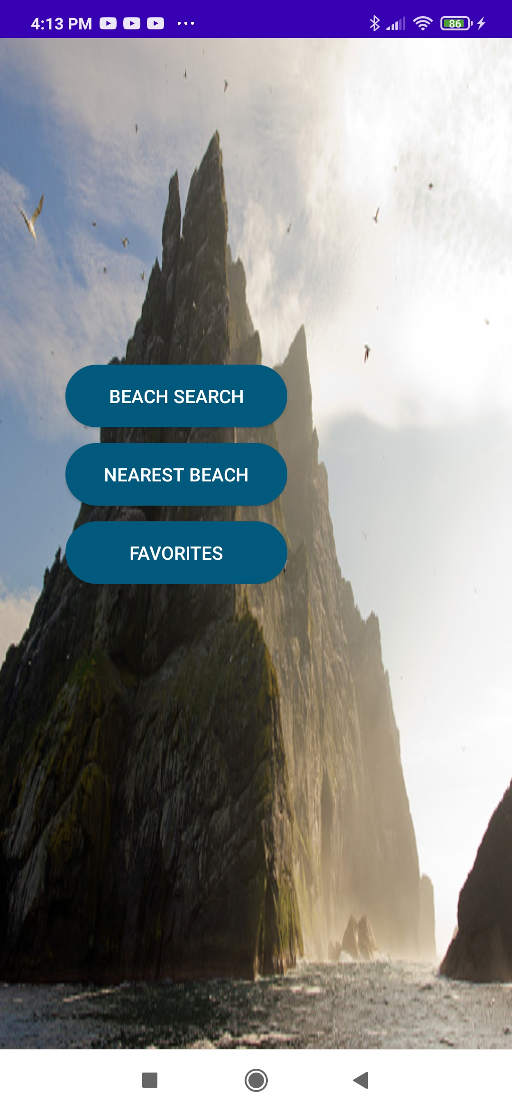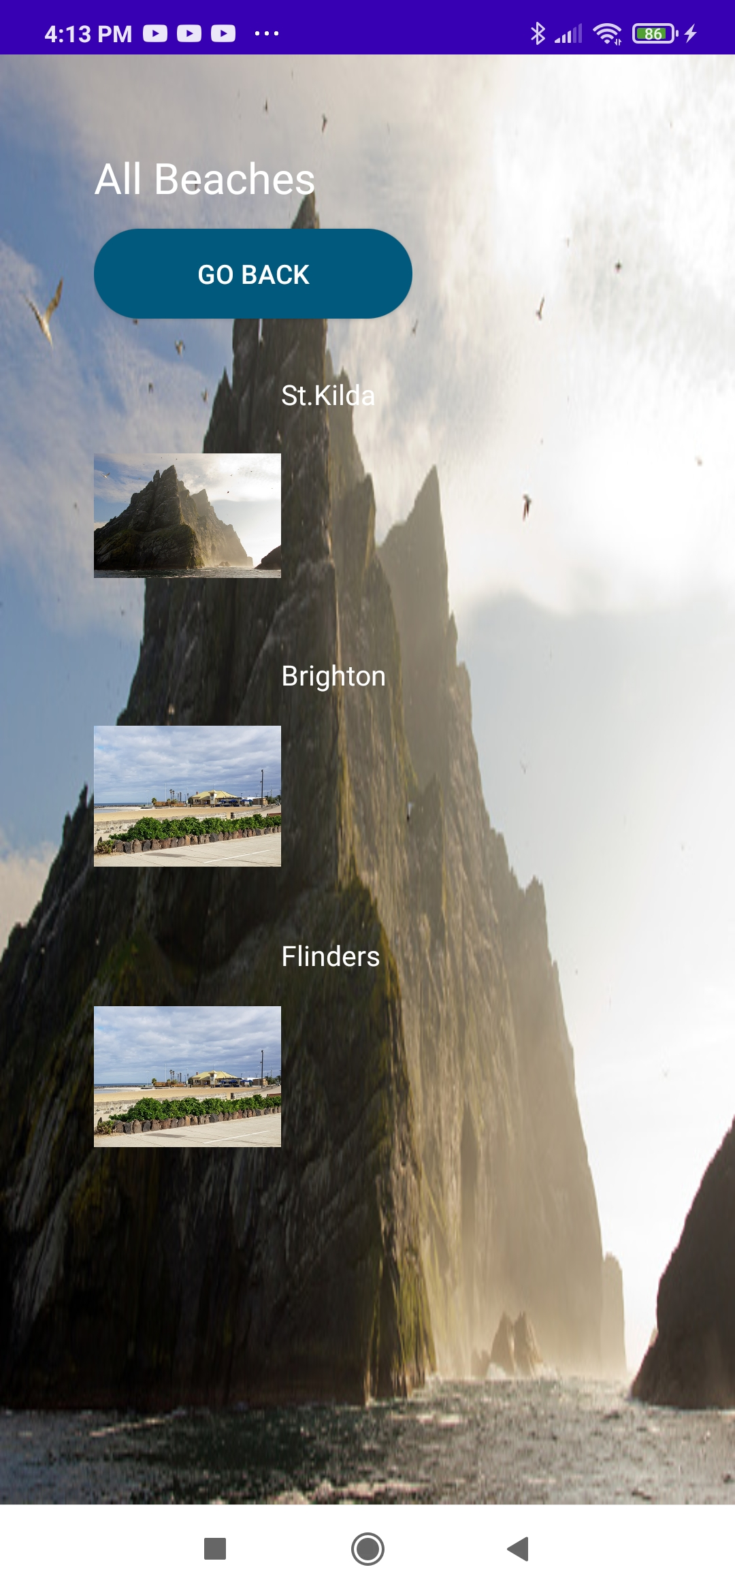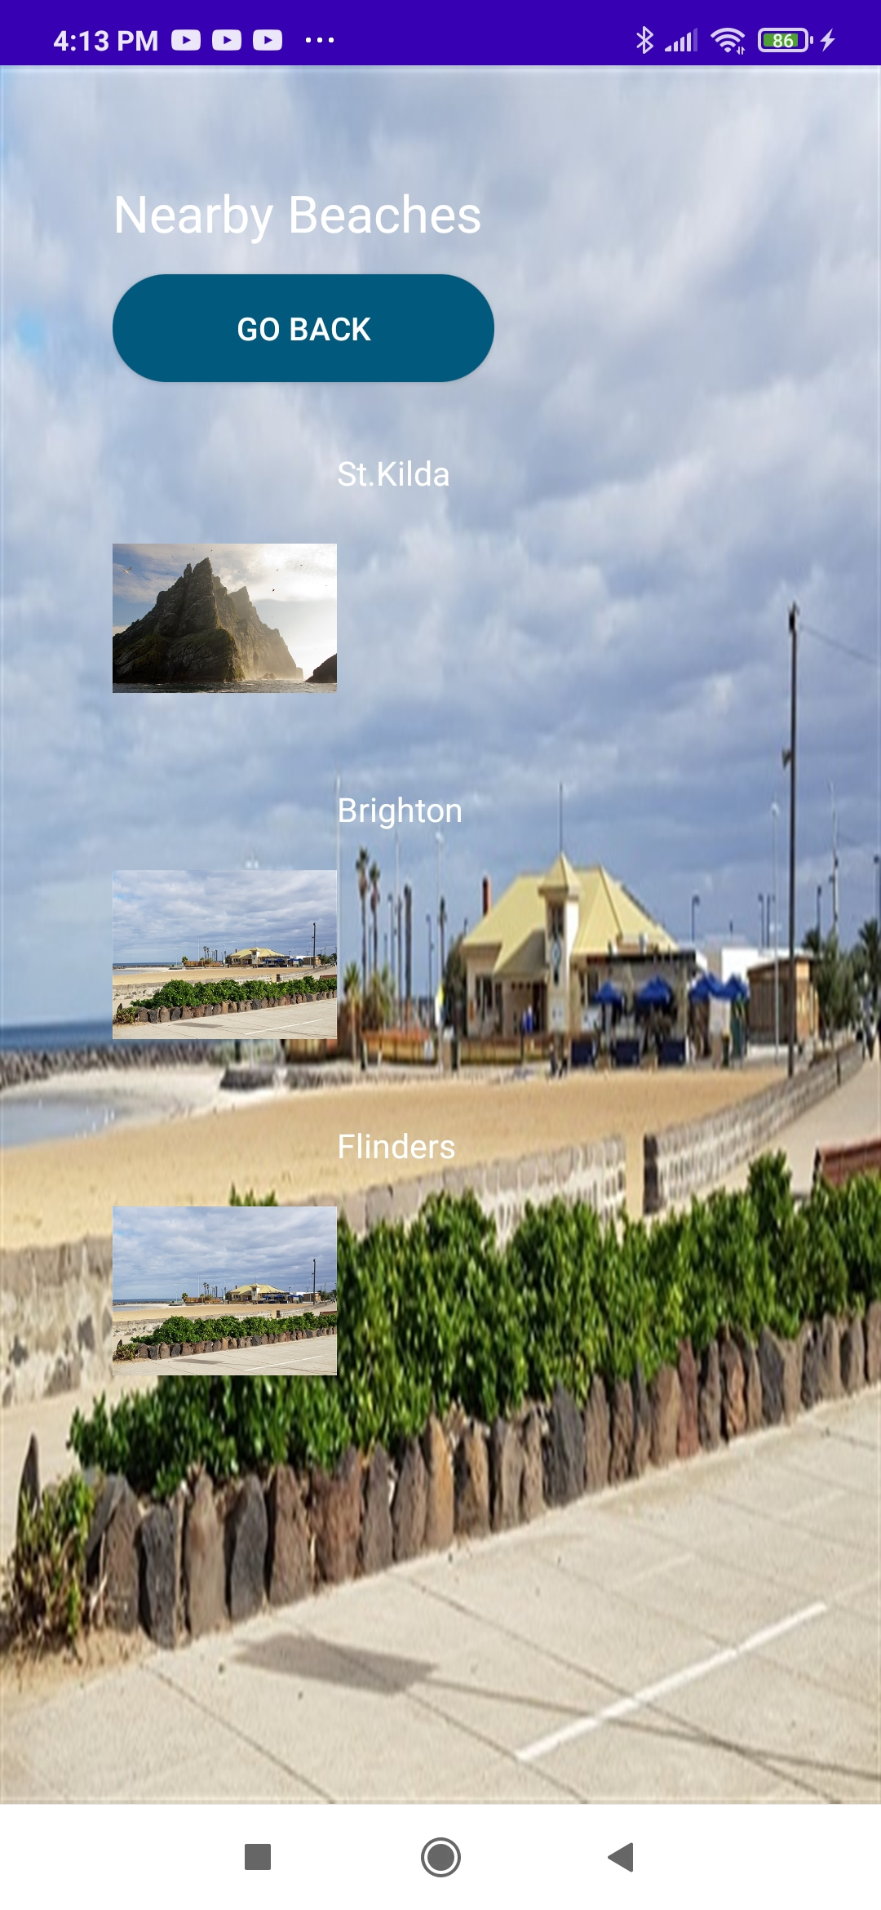

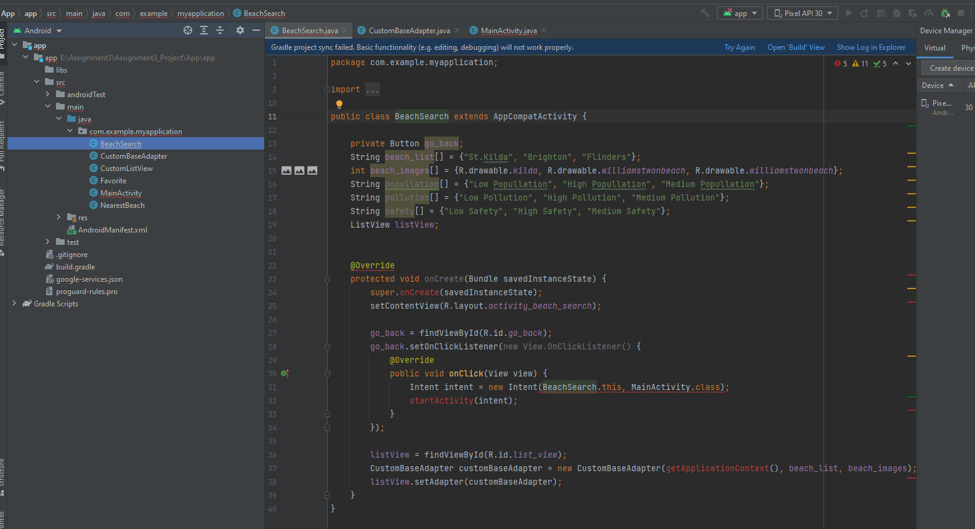

Disclaimer: I understand this is not the best application to submit but given that I did it all on my own while focusing on other assignments, this is all I could get. These are all the screens of the application.

## Artifacts of Nate:

N/a

## Group Reflections:

Chris Turner:

**What went well?**

The communication did improve quite a bit with us also starting a discord server as a fallback if we weren’t able to get into contact with someone soon enough on MS Teams, and we surprisingly got quite a few artifacts done despite with life obligations and other classes/courses getting in the way.

**What could be improved?**

Many of us still didn’t complete our parts until the due week or even due weekend, me included this time. People could still sometimes take a bit too long to get back and keeping track of what people have completed remained the same as last time (doing it in their own thing, not giving regular updates, etc). A group member went MIA towards end and couldn’t get in contact in time for them to finish their group reflection, for example. This makes for the second group member to go MIA.

**At least one thing that was surprising?**

The most surprising thing was how much my lack of motivation and most likely others impacted the quality of our work, and just how suddenly and quickly that can happen. It is an under-looked factor when planning for worst case scenarios and I was not expecting it to happen at all, especially seeing as how I was completely motivated all throughout the last assignment. The assignment suffered a lot because of my loss of motivation, leading to less regular checkups/progress reports.

**At least one thing you have learned about groups?**

How rapidly the work effort of the group can change, for better or worse. This then leads to a bit of chaos and otherwise uneeded stress as things are left very late and rushed and there is not much you can do about group members loss of motivation or life obligations getting in the way. The most you can really do is pray things will get done (unless you somehow manage to find the time to complete other people’s work for them). Although at the same time it’ vert s important to consider everyone has their own stuff going on in life which may serve as a justification for the lack of work ethic, and to be patient with them.

**Group Activity/Contribution:**

I contributed: database related artifacts, timeframe/deadlines, roles, tools (GitHub website), organizing communications and meetings.

Nate Winter:

**MIA, could not get in contact in time**

Connor O’Loughlin:

**What went well?**

I think that my experimentation with figma and eventual resulting prototype was something that went well and was fun to do working without much error or headaches

**What could be improved?**

The speed of completion could have been improved with some people not contributing or mentioning their contributions until even the very end of the due date where some people still did not include their work until the last second

**At least one thing that was surprising:**

I found it surprising how poor the rate of communication got especially after the drastic improvement of the last semester with some people not even showing up to the in-person classes. This heavily negatively impacted our ability to have our work completed properly and have reasonable stress levels.

**At least one thing that you have learned about groups?**

I have learnt that you need to promote frequent communication throughout the entire project because if it falls off it is extremely difficult to get back on track.

Sean Shlemoon:

**What went well?**

I believe that our communication in general improved in between the past assignment and this one, as well as managing our time for work towards this project. I also believe that our understanding of what exactly our project idea was trying to achieve was at a better position and gave us insight in providing more detailed and quality work towards the report.

**What could be improved?**

As much as we did improve on communication, I still think it needs to be worked out much more. As we each have our own lives and responsibilities to attend to, it can be difficult at times to be able to talk to one another and see where we’re at.

**At least one thing that was surprising:**

One thing that was surprising was the type of work I was doing for the project. It gave me a new perspective on group work and provided me with an understanding of what exactly I can expect and what I need to do in order to work more efficiently within a group. I also will be trying to see if I can implement what I’ve contributed towards the report into a real-world application.

**At least one thing you have learned about groups?**

One thing that I have learned about groups and group work is that at times it can be a bit frustrating. We can’t force others to do work they don’t want to, so it can add a level of difficulty to work with others and expect them to contribute. I still believe that it is a necessary thing people need to go through to understand others and provide a degree of experience to know what to do under group circumstances.

**Group Activity/Contribution:**

I contributed sections of the description (Plans and Progress, Scopes and Limits, Testing, Risks) as well as the Use Case Diagram for our project idea.

Kowsar Rahman:

**What went well?**

Communication improved a lot, and everyone got a fair chance of sharing their ideas. Team members got more determined to achieve high marks after a turbulent period originating from the previous assignment.

**What could be improved?**

We could have met face-to-face for some meetings in that way the work could have been done more quickly and feedback could be provided. I totally understand for some of us this option might not be possible due to factors like work commitments, other subject priorities, etc. Hence, I do not strongly advocate for this practice.

**At least one thing that was surprising:**

App development is exceedingly difficult. I faced a lot of difficulties in setting up the emulators to test. Initially, I tried with React Native, but this process turned out to be a disaster however it did show some progress. I didn’t want to go further since I was running out of time. I then switched to Android App Development, and it was again not that hard. Overall, could build the **apk** and the app can run on any Android device.

**At least one thing that you have learned about groups?**

It is everyone’s responsibility to get the best out of the team. Also, no matter what task is allocated from the beginning, it is a recommended approach to have knowledge of other stuff as well.

**Overall Group Reflection:**

Upon discussion as a group, we all agree with each other's individual reflections of the group.

**What went well?**

Compared to the last assignment, we believe that communication was overall better for the duration of assignment 3. We went ahead and created a Discord as a backup means of communication as that serves as a much better way of instant communication and had meetings that were a bit lengthier than usual and despite any lack of motivation, we still ended up having quite a bit of determination left in order to get our report tasks and artifacts completed.

**What could be improved?**

Even if communication did improve when compared with the last assignment, we still don’t believe it to be enough of an improvement. Too often it felt like that we were too unaware of how other members were progressing with their assigned tasks and when we could estimate those tasks be completed. Meetings also begun to lack, with less people turning up to both the online meetings via MS Teams and the in person Friday meetings. This lack of communication is made even harder when a team member begins to drift off, eventually not knowing where they are or what they have been doing.

**At least one thing that was surprising:**

We were surprised at our respective tasks. On one hand, we were surprised at how there can be unexpected difficulties for something that you at first go into feeling very confident, but then a spanner gets thrown into the works and suddenly you have to rethink how you approach the problem. This is an important thing to plan ahead/account for in future project work.

Another thing we found surprising was the large drop off in terms of communication and work ethic out of nowhere. Towards the end of the last assignment, it seemed like things rapidly improved and was going to stay that way for us to find out that somewhat the opposite happened as we begun the project. As expected, our quality of work suffered a lot because of this leading to a lot of rushed work.

**At least one thing that you have learned about groups?**  
We all learnt our own things about working in groups this assignment. Though if we had to choose one thing as the main takeaway here, it’s that how quickly things can fall apart, and it can be very frustrating when you believe that you have put in sufficient effort meanwhile others are letting you down. It’s also important to play to everyone’s strengths and weaknesses as this allows things to get completed to a good standard and at an acceptable pace which may help avoid this sort of thing. It is hard to recover from things falling apart (such as a lack of communication).